**Project 1: Draw Something Cool in 3D**

**Screenshot**

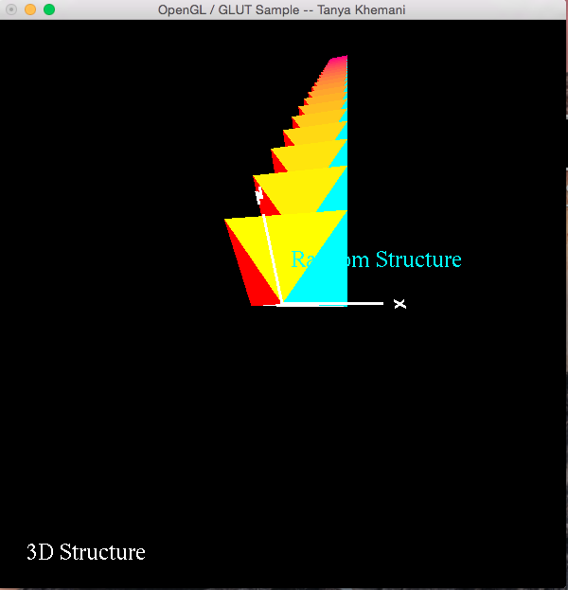

**Youtube Video Link:**

[**https://youtu.be/Iz6HkTuL4J4**](https://youtu.be/Iz6HkTuL4J4)